Exploring the environmental impact of platform chemicals through prospective life cycle analysis

Abhinandan Nabera¹, Antonio José Martín¹, Ioan-Robert Istrate², Javier Pérez-Ramírez¹*, Gonzalo Guillén-Gosálbez¹*
¹Department of Chemistry and Applied Biosciences, ETH Zurich, 8093 Zurich, Switzerland
²Institute of Environmental Sciences (CML), Leiden University, Einsteinweg 2, 2333 CC Leiden, The Netherlands
*jpr@chem.ethz.ch, gonzalo.guillen.gosalbez@chem.ethz.ch

Introduction
Traditional production pathways of platform chemicals like ammonia and methanol are heavily dependent on fossil fuels, resulting in significant CO₂ emissions (560 Gt y^{–1}).¹ In contrast, recent developments have introduced low-carbon production routes, utilizing green hydrogen, with their environmental performance evaluated through life cycle assessments (LCAs).^{2,3} However, it is crucial to recognize that meeting climate targets will necessitate substantial changes in the economy, including the decarbonization of energy production and transportation. Hence, in this work, we conduct a prospective life cycle assessment (pLCA) until 2050 to investigate how future economic trends could impact the environmental footprint of chemical production routes.

Methods
We utilize an Integrated Assessment Model (IAM) called IMAGE⁴ to quantify the environmental impacts of both fossil and green ammonia and methanol production routes. This allows us to project future economic scenarios and offers insights into the environmental impacts based on expected socio-economic and technological developments. Specifically, we adopt the intermediate shared socio-economic pathway (SSP2) and consider various representative concentration pathways (RCPs), including RCP6, RCP2.6, and RCP1.9, to generate a range of scenarios reflecting economic changes. To construct inventories for pLCAs spanning from 2020 to 2050, we employ the premise⁴ (v1.5.9) framework. Furthermore, we enhance the temporal resolution for the production of these chemicals to 26 regions worldwide, considering location-specific temporal profiles.

Results and Discussion
In contrast to fossil-based routes, the estimated climate change impacts of solar and wind-based ammonia (Figure 1a) and methanol (Figure 1b) production routes show a promising trend, with significant reductions anticipated by 2050. Under more ambitious climate policies, such as the 1.5 °C scenario, these impacts are expected to decrease substantially. Specifically, by 2050, solar-based ammonia and methanol are projected to achieve a 71% and 102% reduction, respectively. In summary, solar-based production routes exhibit the most substantial reductions in environmental impacts over time, approaching the performance levels achieved by their wind-based counterparts. Furthermore, a regional analysis reveals that the relative climate change impact reductions for solar-based ammonia and methanol production, impact reductions vary significantly by region, emphasizing the importance of location-based dynamics for strategic planning.

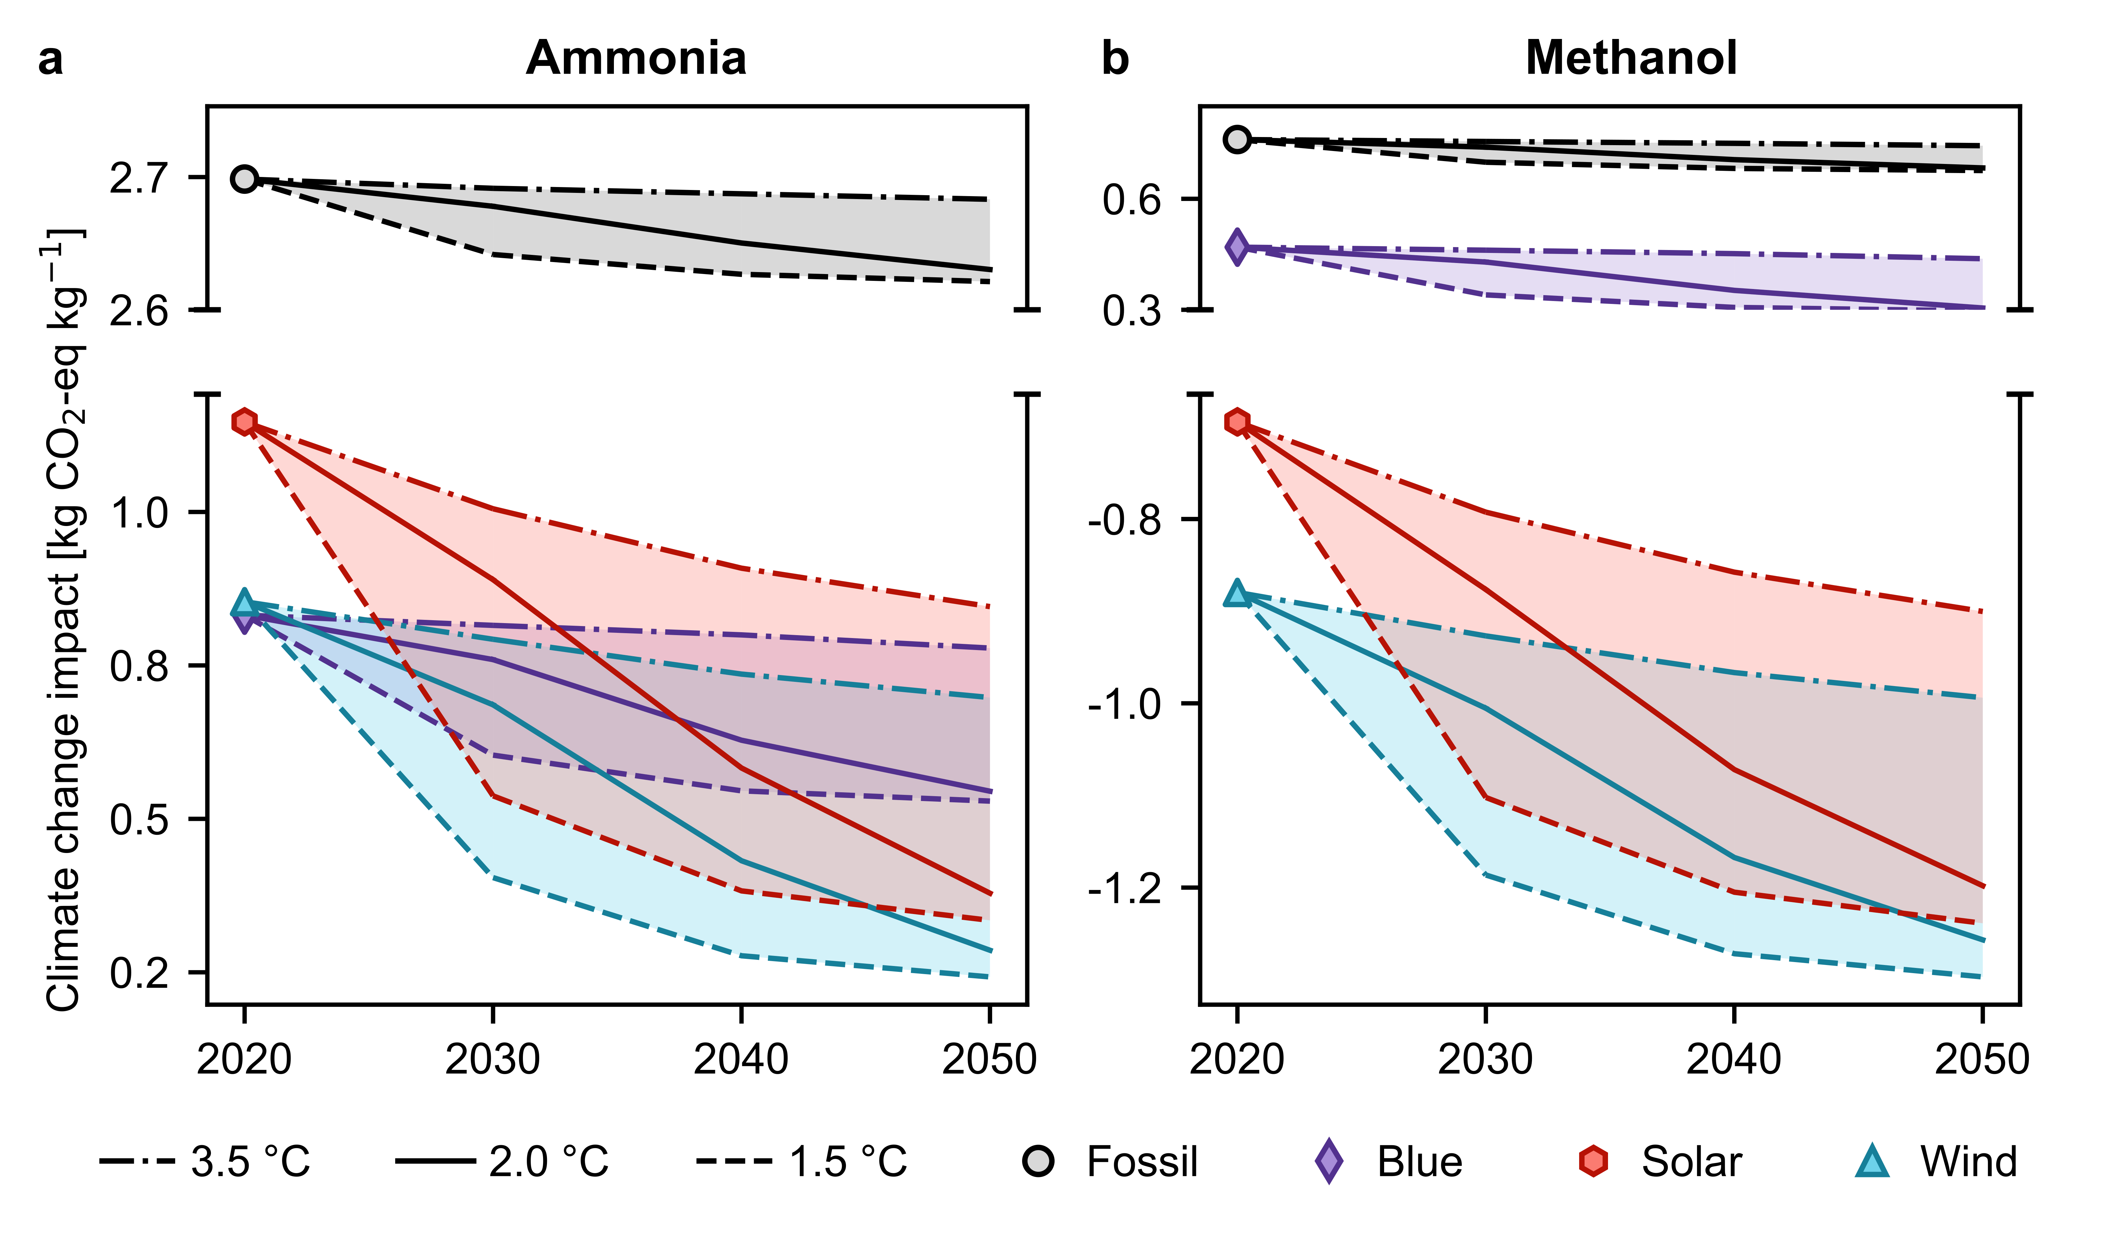
Figure 1. Global average climate change impacts of fossil, blue, and green (both solar and wind-based) production of (a) ammonia and (b) methanol from 2020 to 2050 across three climate policy scenarios (3.5 °C, 2 °C, and 1.5 °C).

Significance
Our results offer a more comprehensive outlook on the environmental performance of various production routes for the most important platform chemicals, thereby revealing the realistic possibilities of fossil and low-carbon-based production routes in the context of foreseeable socio-economic and technological developments.

References
1 P. Gabrielli, L. Rosa, M. Gazzani, R. Meys, A. Bardow, M. Mazzotti and G. Sansavini, One Earth, 2023, 6, 682.
2 S. C. D’Angelo, S. Cobo, V. Tulus, A. Nabera, A. J. Martín, J. Pérez-Ramírez and G. Guillén-Gosálbez, ACS Sustainable Chem. Eng., 2021, 9, 9740.
3 A. González-Garay, M. S. Frei, A. Al-Qahtani, C. Mondelli, G. Guillén-Gosálbez and J. Pérez-Ramírez, Energy Environ. Sci., 2019, 12, 3425.
4 R. Sacchi, T. Terlouw, K. Siala, A. Dirnaichner, C. Bauer, B. Cox, C. Mutel, V. Daioglou and G. Luderer, Renewable and Sustainable Energy Reviews, 2022, 160, 112311.

